LEC SAD W5
Question 1: Should we include caculated data in table, why or why not?
No, we should not include calculated data in tables. This is because storing the results of calculations, such as subtotals or totals, can be redundant and lead to potential data inconsistencies. Instead, calculations should be performed dynamically when needed. For example, if you need to see a subtotal of units on order for a report, it's better to have the system calculate the subtotal using the raw data stored in the table, rather than storing the subtotal itself. This ensures accuracy and keeps the database streamlined.
Question 2: Why we need to iterate database design process?
We need to iterate the database design process for several key reasons:

1. Error Identification and Correction: Initial designs often contain mistakes or inefficiencies. Iteration helps identify and correct these issues early in the process, improving the database’s accuracy and reliability.

2. Optimization: As requirements evolve, iterating allows for the optimization of the database structure. This ensures that the database performs efficiently with growing data volumes and changing query needs.

3. Meeting Changing Requirements: Business or user needs often change during development. Iterating the design ensures that the database remains flexible and adaptable to these changes.

4. Improving Normalization: Iteration allows for better normalization, reducing redundancy, improving data integrity, and enhancing data consistency across tables.

5. Testing and Feedback: Each iteration allows for testing and feedback. This helps refine the database to better suit the real-world use case and data processing needs.

In summary, iterating the database design process helps create a robust, efficient, and scalable system that adapts to evolving requirements and prevents potential issues from affecting long-term performance.
Question 3: Give examples of 3 types of table relationship?
Here are examples of three types of table relationships in a database:

1. One-to-One Relationship:
- Example: Consider a database with a `Users` table and a `Profiles` table. Each user can have only one profile, and each profile belongs to only one user.
- Tables:
- `Users`: UserID (Primary Key), Username, Email
- `Profiles`: ProfileID (Primary Key), UserID (Foreign Key), Bio, ProfilePicture

2. One-to-Many Relationship:
- Example: In a database with a `Customers` table and an `Orders` table, one customer can place multiple orders, but each order is associated with only one customer.
- Tables:
- `Customers`: CustomerID (Primary Key), Name, Email
- `Orders`: OrderID (Primary Key), CustomerID (Foreign Key), OrderDate, TotalAmount

3. Many-to-Many Relationship:
- Example: In a database with a `Students` table and a `Courses` table, a student can enroll in multiple courses, and each course can have multiple students. This relationship is typically managed by a junction table.
- Tables:
- `Students`: StudentID (Primary Key), Name, Major
- `Courses`: CourseID (Primary Key), CourseName, Credits
- `Enrollments` (junction table): EnrollmentID (Primary Key), StudentID (Foreign Key), CourseID (Foreign Key)

These relationships help structure the data in a way that reflects real-world associations among entities.
Question 4: The purpose of achieving First Normal Form (1NF) in database design includes the following key objectives:

1. Eliminating Duplicate Data:
- Purpose: 1NF requires that each column in a table contains atomic (indivisible) values, which helps eliminate duplicate data within the same column.
- Example: Instead of having a column for multiple phone numbers (e.g., "555-1234, 555-5678"), you would create separate rows for each number.

2. Ensuring Data Integrity:
- Purpose: By enforcing that each entry in a column is of the same data type and atomic, 1NF helps maintain consistency and integrity of the data.
- Example: A column for `DateOfBirth` should contain only date values, ensuring no invalid entries like text or mixed formats.

3. Facilitating Data Manipulation:
- Purpose: With data organized in a structured way, it becomes easier to query, update, and manage the data efficiently.
- Example: It is simpler to perform queries to retrieve specific records when each field is clearly defined and separated.

4. Establishing a Clear Table Structure:
- Purpose: Achieving 1NF provides a clear and straightforward table structure, making it easier to understand and use the database.
- Example: Each table should represent a single entity with clearly defined attributes, making the design more intuitive.

5. Laying the Foundation for Further Normalization:
- Purpose: 1NF is the first step in the normalization process, setting the groundwork for achieving higher normal forms (2NF, 3NF, etc.) which further reduce redundancy and improve data integrity.
- Example: Once in 1NF, you can work on eliminating partial and transitive dependencies to reach 2NF and 3NF.

In summary, achieving 1NF is crucial for creating a well-structured, efficient, and reliable database.
Question 5: Purpose of 2NF
The motivation behind achieving Second Normal Form (2NF) in database design includes several important objectives:

1. Eliminating Partial Dependencies:
- Purpose: 2NF requires that all non-key attributes are fully functionally dependent on the entire primary key. This eliminates partial dependencies, where a non-key attribute depends only on part of a composite primary key.
- Example: If you have a table with a composite key (e.g., `OrderID` and `ProductID`), a column like `ProductName` should not depend solely on `ProductID`; it should be moved to a separate table.

2. Reducing Data Redundancy:
- Purpose: By ensuring that non-key attributes are only associated with the full primary key, 2NF reduces redundancy, which can lead to inconsistencies and errors.
- Example: If `ProductName` is stored in multiple rows for each order, updating the product name in one row but forgetting to update others would cause inconsistencies.

3. Enhancing Data Integrity:
- Purpose: 2NF helps maintain data integrity by ensuring that all attributes are related to the entire primary key, which prevents anomalies during data operations (insertion, deletion, and updating).
- Example: If you delete an order, you should not lose information about the product that might be required for future records.

4. Improving Query Performance:
- Purpose: A well-structured database in 2NF can lead to more efficient queries since the data is organized logically without unnecessary duplication.
- Example: Queries that retrieve product details won't have to sift through redundant data, making them faster and more efficient.

5. Facilitating Maintenance and Scalability:
- Purpose: A normalized database is easier to maintain and scale. Changes to the schema or business rules can be implemented more straightforwardly without affecting unrelated data.
- Example: If a new product attribute needs to be added, it can be done in the product table without impacting other tables.

In summary, achieving 2NF is essential for creating a more organized, efficient, and reliable database that minimizes redundancy and maintains data integrity.

Question 6: 3NF purpose
Achieving Third Normal Form (3NF) is crucial in database design for several reasons:

1. Eliminating Transitive Dependencies:
- Purpose: 3NF requires that non-key attributes are not only dependent on the primary key but also independent of each other. This eliminates transitive dependencies, where one non-key attribute depends on another non-key attribute.
- Example: If you have a table with `EmployeeID`, `DepartmentID`, and `DepartmentName`, the `DepartmentName` should not be included in the same table because it depends on `DepartmentID`, not directly on `EmployeeID`.

2. Reducing Data Redundancy:
- Purpose: By eliminating transitive dependencies, 3NF reduces redundancy in the database, which can help prevent inconsistencies in the data.
- Example: Storing department names in multiple employee records can lead to discrepancies if a department name changes.

3. Improving Data Integrity:
- Purpose: 3NF enhances data integrity by ensuring that data is only stored in one place. This makes it easier to maintain accurate and consistent data throughout the database.
- Example: If a department name needs to be updated, it can be done in one location rather than in multiple rows, reducing the chance of errors.

4. Facilitating Easier Maintenance:
- Purpose: A database in 3NF is generally easier to maintain and modify. Changes can be made without significantly affecting other parts of the database structure.
- Example: Adding a new attribute related to departments can be done in the department table without affecting employee records.

5. Enhancing Query Efficiency:
- Purpose: Queries can be more efficient and straightforward, as the structure is cleaner and more logically organized, making it easier to retrieve related data.
- Example: If you want to join tables to get employee and department information, the relationships will be clearer without unnecessary dependencies.

In summary, achieving 3NF is essential for creating a well-structured, efficient, and reliable database that minimizes redundancy, maintains data integrity, and simplifies maintenance and querying.
Question 7: Transform 2NF to 3NF
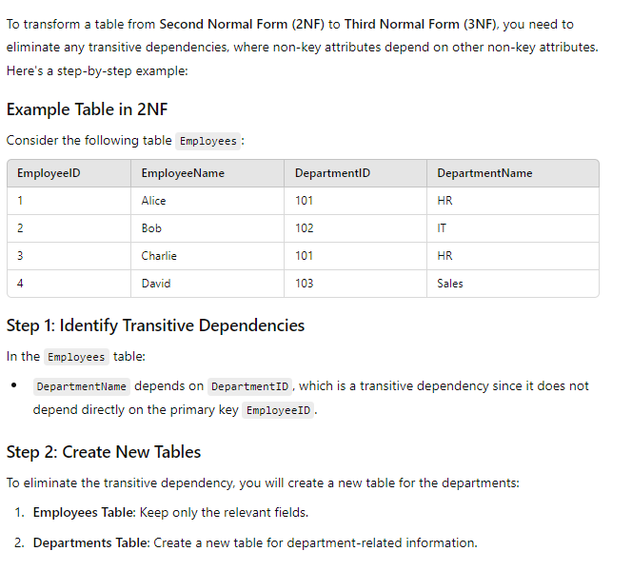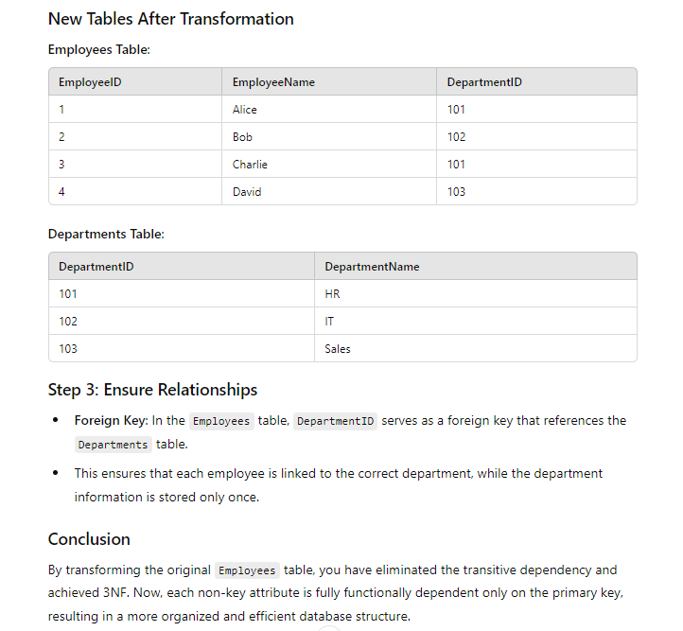
Question 8: Examples violate nomalization rule
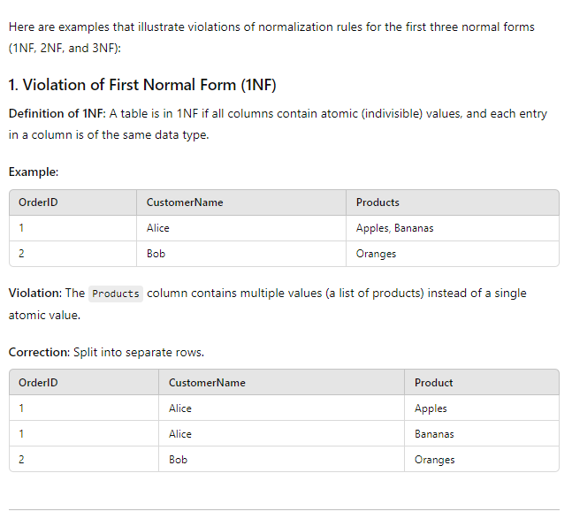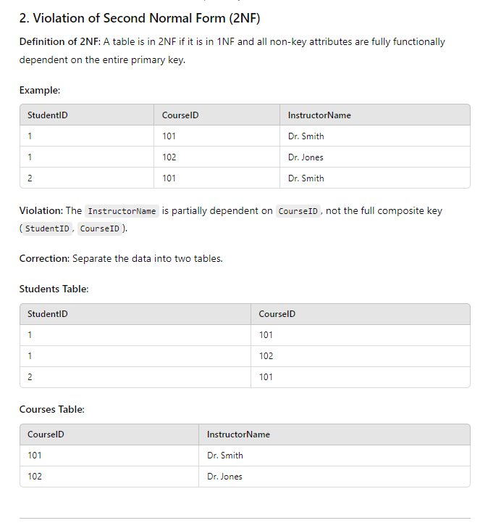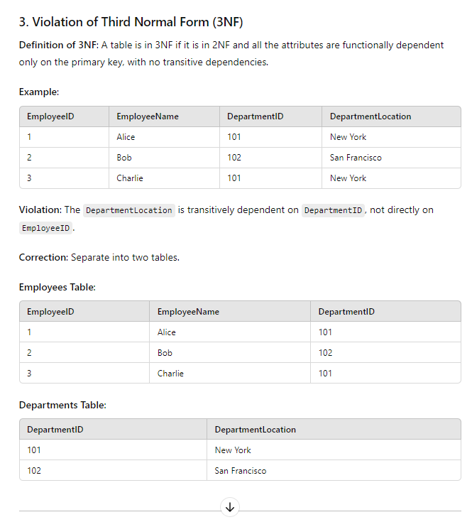
Question 9: Explain the process of "discover & collect information" (V1)?
Process of "Discover & Collect Information" in Database Design (V1)

The "Discover & Collect Information" phase is the foundational step in database design, focused on gathering the necessary data and refining the design. Here’s a detailed breakdown:

1. Identify Data Requirements:
- Determine what information needs to be stored.
- This includes understanding the purpose of the database, the business requirements, and the key entities (e.g., customers, orders, products) that the system must manage.

Example: In an e-commerce system, you would identify data such as customer details, product information, and order transactions.

2. Collect Data from Stakeholders:
- Engage with business users or stakeholders to gather insights about the data they work with.
- Identify the attributes (fields) for each entity, and understand how they relate to each other.

Example: A stakeholder might explain that each order must include the customer’s shipping address, order date, and product information, which helps you identify those fields for the "Orders" table.

3. Analyze Data Relationships:
- Explore how different data entities interact with each other, and identify relationships like one-to-one, one-to-many, or many-to-many.
- Ensure that each relationship is well-defined and supported by proper table design.

Example: A "Customer" can place multiple "Orders" (one-to-many relationship), but an "Order" can only belong to one "Customer".

4. Prototype and Test Data Structure:
- Create initial table structures and populate them with sample data to evaluate whether the relationships and fields are sufficient.
- Conduct tests by running queries, adding or deleting data to see if the structure is logical and efficient.

Example: After designing tables for "Customers" and "Orders," test queries like "Which customers placed orders in the last month?" to validate the design.

5. Refine Based on Feedback:
- As you work with the sample data and test your database, you may discover missing fields, unnecessary columns, or opportunities to normalize the data structure further.
- Make iterative adjustments to improve the design.

Example: You realize that orders also need to track delivery status, so you add a "DeliveryStatus" column to the "Orders" table.

6. Document Findings:
- Document the data you have collected, the decisions made about relationships, and the structure of the database tables.
- This helps ensure that all stakeholders have a clear understanding of the database and its purpose.

Example: Record that the "Orders" table links to the "Customers" table via a "CustomerID" field to maintain clarity on relationships.

Conclusion

The "Discover & Collect Information" process helps gather, analyze, and refine the data requirements and relationships that will shape the database. This ensures that the design supports the business needs effectively while maintaining a scalable, organized structure.
Question 10: Should we reduce data redundancy entirely? and Why?

While it may seem beneficial to completely eliminate data redundancy, it is not always the best approach. Here’s why:

Why Reducing Data Redundancy is Important:
1. Improves Data Integrity:
- When data is duplicated, any updates or changes must be applied consistently across all instances. Reducing redundancy ensures data consistency.
- Example: If customer information is stored in multiple places, changing their address in one location but forgetting others leads to inconsistency.

2. Saves Storage Space:
- Storing the same data multiple times wastes storage. Reducing redundancy can save space, especially with large datasets.
- Example: Instead of storing a product description multiple times in different order records, you store it once in a "Products" table and link to it.

3. Eases Maintenance:
- A database with minimal redundancy is easier to update. When changes are made, they need to be applied in fewer places, reducing the risk of errors.
- Example: Updating an employee's salary should occur in one place, not across multiple records.

Why Not Eliminate Redundancy Entirely:
1. Performance Trade-offs:
- Completely eliminating redundancy might slow down performance because it requires more complex queries and joins between multiple tables to retrieve data.
- Example: If every time you want to display a full order, you need to join multiple tables, the query might take longer, especially with large datasets.

2. Practical Needs for Denormalization:
- In some cases, keeping some redundancy (denormalization) is necessary to improve read performance, especially in large-scale systems where quick access to data is critical.
- Example: A reporting database might intentionally keep redundant data to avoid complex joins and speed up the generation of reports.

Conclusion:
Reducing redundancy is essential for maintaining data integrity and saving space. However, it should not be eliminated entirely, as some level of redundancy can be beneficial for performance optimization in certain use cases. Therefore, the decision to reduce or allow redundancy should be balanced with the system’s performance and operational requirements.
Question 11: How does physical design differ from logical design?
Level of Detail:
Logical Design focuses on the abstract structure, defining entities, relationships, and normalization without concern for the physical implementation.
Physical Design specifies the actual implementation, defining tables, columns, data types, and constraints.
Implementation Consideration:
Logical Design is independent of the specific DBMS and does not deal with data types or storage details.
Physical Design is dependent on the chosen DBMS, where each column has a specific data type and other physical attributes based on the system used (e.g., MySQL, SQL Server).
Normalization vs. De-normalization:
Logical Design typically emphasizes normalization to remove data redundancy.
Physical Design might introduce de-normalization for performance optimization, adjusting the design for practical implementation.

Question 12: skipping one of the three data models (Conceptual, Logical, or Physical)
No, skipping one of the three data models (Conceptual, Logical, or Physical) in the database design process is generally not recommended because each model serves a distinct and important purpose:

1. Conceptual Data Model – Defines what data is needed, focusing on the high-level structure of the system. It helps business stakeholders and data architects understand the overall business concepts and relationships.
- If skipped: The design may lack a clear understanding of business requirements, leading to miscommunication and poor alignment with organizational goals.

2. Logical Data Model – Focuses on how the data should be structured independently of the DBMS, including entities, relationships, and attributes. This is critical for ensuring data integrity, normalization, and meeting technical requirements.
- If skipped: The design could become inefficient, with potential data redundancy, inconsistent relationships, or inadequate mapping of business rules.

3. Physical Data Model – Details how the system will be physically implemented in a specific DBMS, including table structures, columns, data types, and performance optimizations.
- If skipped: The system may not be optimized for the actual database used, resulting in poor performance, inefficient queries, or storage issues.

Each model builds on the previous one, refining and adding detail, so skipping any of these phases can lead to incomplete or inefficient database design. All three models ensure that the database is aligned with business requirements, technically sound, and optimized for performance.
Question 13: Which design model need to apply normalization rules?
The Logical Data Model is where normalization rules are applied.

Reasons:
- Purpose of the Logical Data Model: It focuses on the structure and relationships between entities without considering physical implementation details. The goal is to create an optimal and efficient database design by eliminating redundancy and ensuring data integrity.
- Normalization: Normalization is the process of organizing data into multiple related tables to reduce data redundancy and improve data integrity. This process is typically applied during the logical design phase, where entities, attributes, primary keys, and foreign keys are defined.

Key points about normalization in the logical model:
- 1st Normal Form (1NF): Ensures that each attribute contains atomic values and there are no repeating groups.
- 2nd Normal Form (2NF): Removes partial dependencies, ensuring that every non-key attribute is fully dependent on the primary key.
- 3rd Normal Form (3NF): Removes transitive dependencies, ensuring that non-key attributes are not dependent on other non-key attributes.

After applying normalization in the logical model, the resulting design ensures a well-structured database that can be later translated into a physical model for actual implementation.
Question 14: Which model is more important than others, why?
No single data model is inherently more important than the others, as each serves a distinct and critical role in the overall database design process. However, their importance depends on the specific context and stage of database development:

Conceptual Model:
- Importance: Defines what data is needed by focusing on the business perspective. It is crucial for understanding business requirements and ensuring that the system aligns with those needs.
- Why it's critical: Without a clear conceptual model, the system may fail to meet business objectives. However, this model lacks technical detail, so on its own, it cannot guide the actual database structure.

Logical Model:
- Importance: Describes how the data should be structured and organized, without being tied to a specific database system. This model is crucial for ensuring proper relationships, data integrity, and normalization.
- Why it's critical: This model acts as the bridge between business requirements and the technical implementation. It ensures that the design is efficient and flexible, addressing how data will interact logically.

Physical Model:
- Importance: Focuses on how the data will be stored in a specific database management system (DBMS), detailing tables, columns, data types, and performance considerations.
- Why it's critical: Without a physical model, the logical design cannot be properly implemented, resulting in a non-functional or poorly optimized database.

Which is more important?
In most cases, the Logical Data Model is considered the most critical because:
- It ensures a well-structured database that eliminates redundancy (through normalization) and maintains data integrity.
- It serves as the blueprint for translating business requirements (Conceptual Model) into an actual database (Physical Model).
- Any errors or inefficiencies in the logical design can cascade into the physical implementation, making it harder to fix issues later.
However, all models are important, as they work together to create an efficient, reliable, and business-aligned database. Each model addresses a specific layer of complexity in the design process. Skipping any one of them can result in a flawed or incomplete system.
Activity:
Designing a logical data model for a Hanu Credit Registration System using an Entity-Relationship (ER) diagram involves defining entities, their attributes, and the relationships between them. Below is a general outline for such a system:
### Entities and Attributes:
1. Student - student_id (Primary Key) - student_name - student_dob - student_address - email - phone_number
2. Course - course_id (Primary Key) - course_name - course_description - units
- Instructor - instructor_id (Primary Key) - instructor_name - instructor_email - phone_number - department
- 4. Department - department_id (Primary Key) - department_name - faculty_name
- 5. Credit_Registration - registration_id (Primary Key) - registration_date - semester - grade
- 6. Semester - semester_id (Primary Key) - semester_name - start_date - end_date
### Relationships:
- Student - Credit Registration - A student can register for many courses (credits), and each credit registration relates to only one student. - Relationship: One-to-Many (One student can have many credit registrations). - Foreign Key: student_id in the Credit_Registration table.
- 2. Course - Credit Registration - A course can have many students enrolled (credit registrations), and each credit registration is associated with one course. - Relationship: One-to-Many (One course can have many credit registrations). - Foreign Key: course_id in the Credit_Registration table.
- 3. Instructor - Course - An instructor can teach many courses, and each course is taught by one instructor. - Relationship: One-to-Many (One instructor can teach many courses). - Foreign Key: instructor_id in the Course table.
- 4. Department - Instructor - A department can have many instructors, but each instructor belongs to only one department. - Relationship: One-to-Many (One department can have many instructors). - Foreign Key: department_id in the Instructor table.
- 5. Course - Department - A department can offer many courses, but each course belongs to one department. - Relationship: One-to-Many (One department can offer many courses). - Foreign Key: department_id in the Course table.
- 6. Credit Registration - Semester - A semester can have many credit registrations, but each credit registration occurs in one semester. - Relationship: One-to-Many (One semester can have many credit registrations). - Foreign Key: semester_id in the Credit_Registration table.

-- ### ER Diagram Overview: - Entities: Student, Course, Instructor, Department, Credit_Registration, Semester. - Relationships: - Student ↔ Credit Registration (One-to-Many) - Course ↔ Credit Registration (One-to-Many) - Instructor ↔ Course (One-to-Many) - Department ↔ Instructor (One-to-Many) - Department ↔ Course (One-to-Many) - Semester ↔ Credit Registration (One-to-Many) You can visualize the ER diagram by connecting entities with lines to show the relationships between them and using the appropriate notation for primary keys and foreign keys. If you need a specific tool-based ER diagram, tools like Lucidchart, draw.io, or MySQL Workbench can help you create the visual diagram easily.

